Math 61 Learning Unit 2 Hand-In Assignment for Section 3.5
© Problems copyright Stefan Waner 2015 All rights reserved

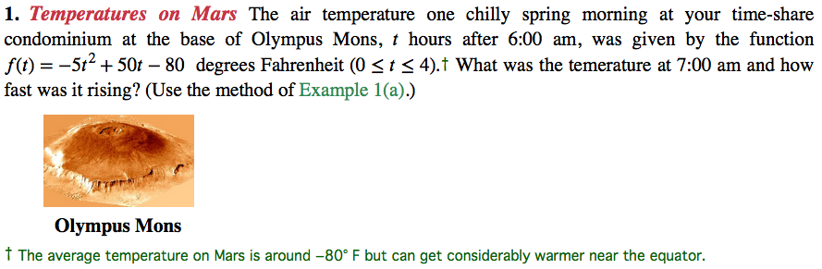
Hint: Use a balanced difference quotient. See Section 3.5 Exercise 85 for a similar problem in the book.

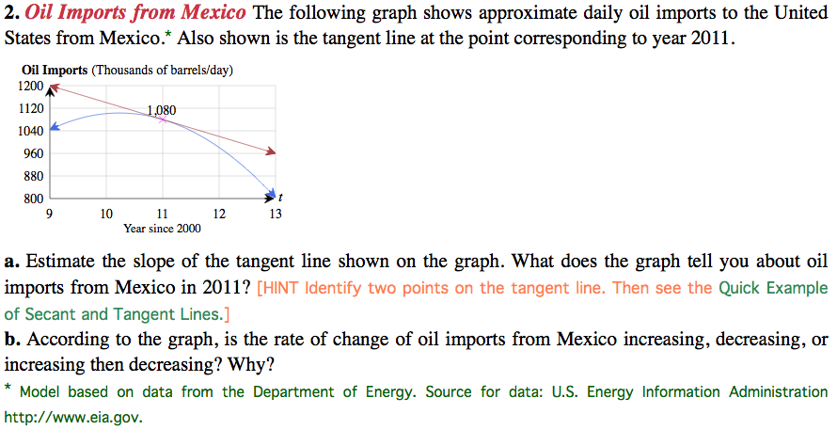
‡ 1980 data estimated. Source: http://www.sciencewatch.com
Hint: Similar to Section 3.5 Exercise 79 in the book.

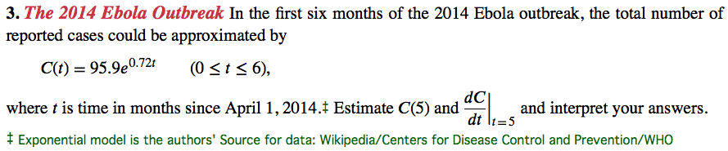
Hint: Similar to Section 3.5 Exercise 87 in the book.

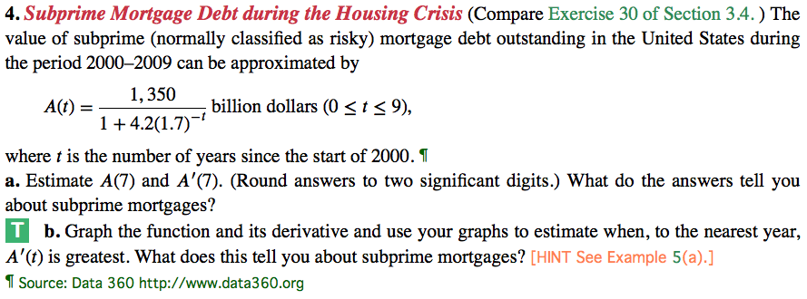
Hint: This is Section 3.5 Exercise 96, similar to Exercise 95 in the book.

5. Sketch the graph of a function whose derivative decreases from 0 to -1 and then increases back to 0.

6. If two functions have the same derivative at every point, how do their graphs compare?

